How to use Zoom

Using the internet or a phone, Zoom allows us to hold online meetings and classes.

Here is how it works:

- I schedule a class.
- I send you the login information.
- At the appointed hour, you connect to the meeting by calling in on your phone, OR by joining the meeting using your computer, mobile phone or tablet.

If you call in, you can only hear me and the other people in the group.

If you use your computer or other device, you also have the ability – if you choose – to permit people to see and hear you, and for you to see and hear everyone else. You’ll also be able to see on your screen any images and documents that I share.

Zoom is fun, and it allows us to be together without swapping germs. Having a robust internet connection is a plus.

To prepare your device to use Zoom, please follow the following steps:

Step #1 – Download the Zoom app on your computer, phone or tablet
It’s free, you don’t have to sign up for anything and takes just a minute or two.
If you’re doing this on your computer:
Click the link below and install the “Zoom Client for Meetings”
https://zoom.us/download

If you’re doing this on your phone or tablet:
Go to the Apple App Store or Google Play Store and install the Zoom app.

Step #2 – Sign In to our Meeting
Once I schedule a meeting, I will email you the information you need to login to that meeting or class. The Meeting ID is class specific and will be different for each class. It will look something like this:

Michael Resnick is inviting you to a scheduled Zoom meeting.

Topic: Adult B'nai Mitzvah Class
Time: Wednesday, Mar 25, 2020 12:30 PM Eastern Time

Meeting ID: 848 728 261

Dial by your location
+1 929 205 6099 US (New York)
+1 312 626 6799 US (Chicago)
+1 669 900 6833 US (San Jose)
+1 253 215 8782 US
+1 301 715 8592 US
+1 346 248 7799 US (Houston)

Join Zoom Meeting
https://zoom.us/j/848728261

#

An open app will look something like this:
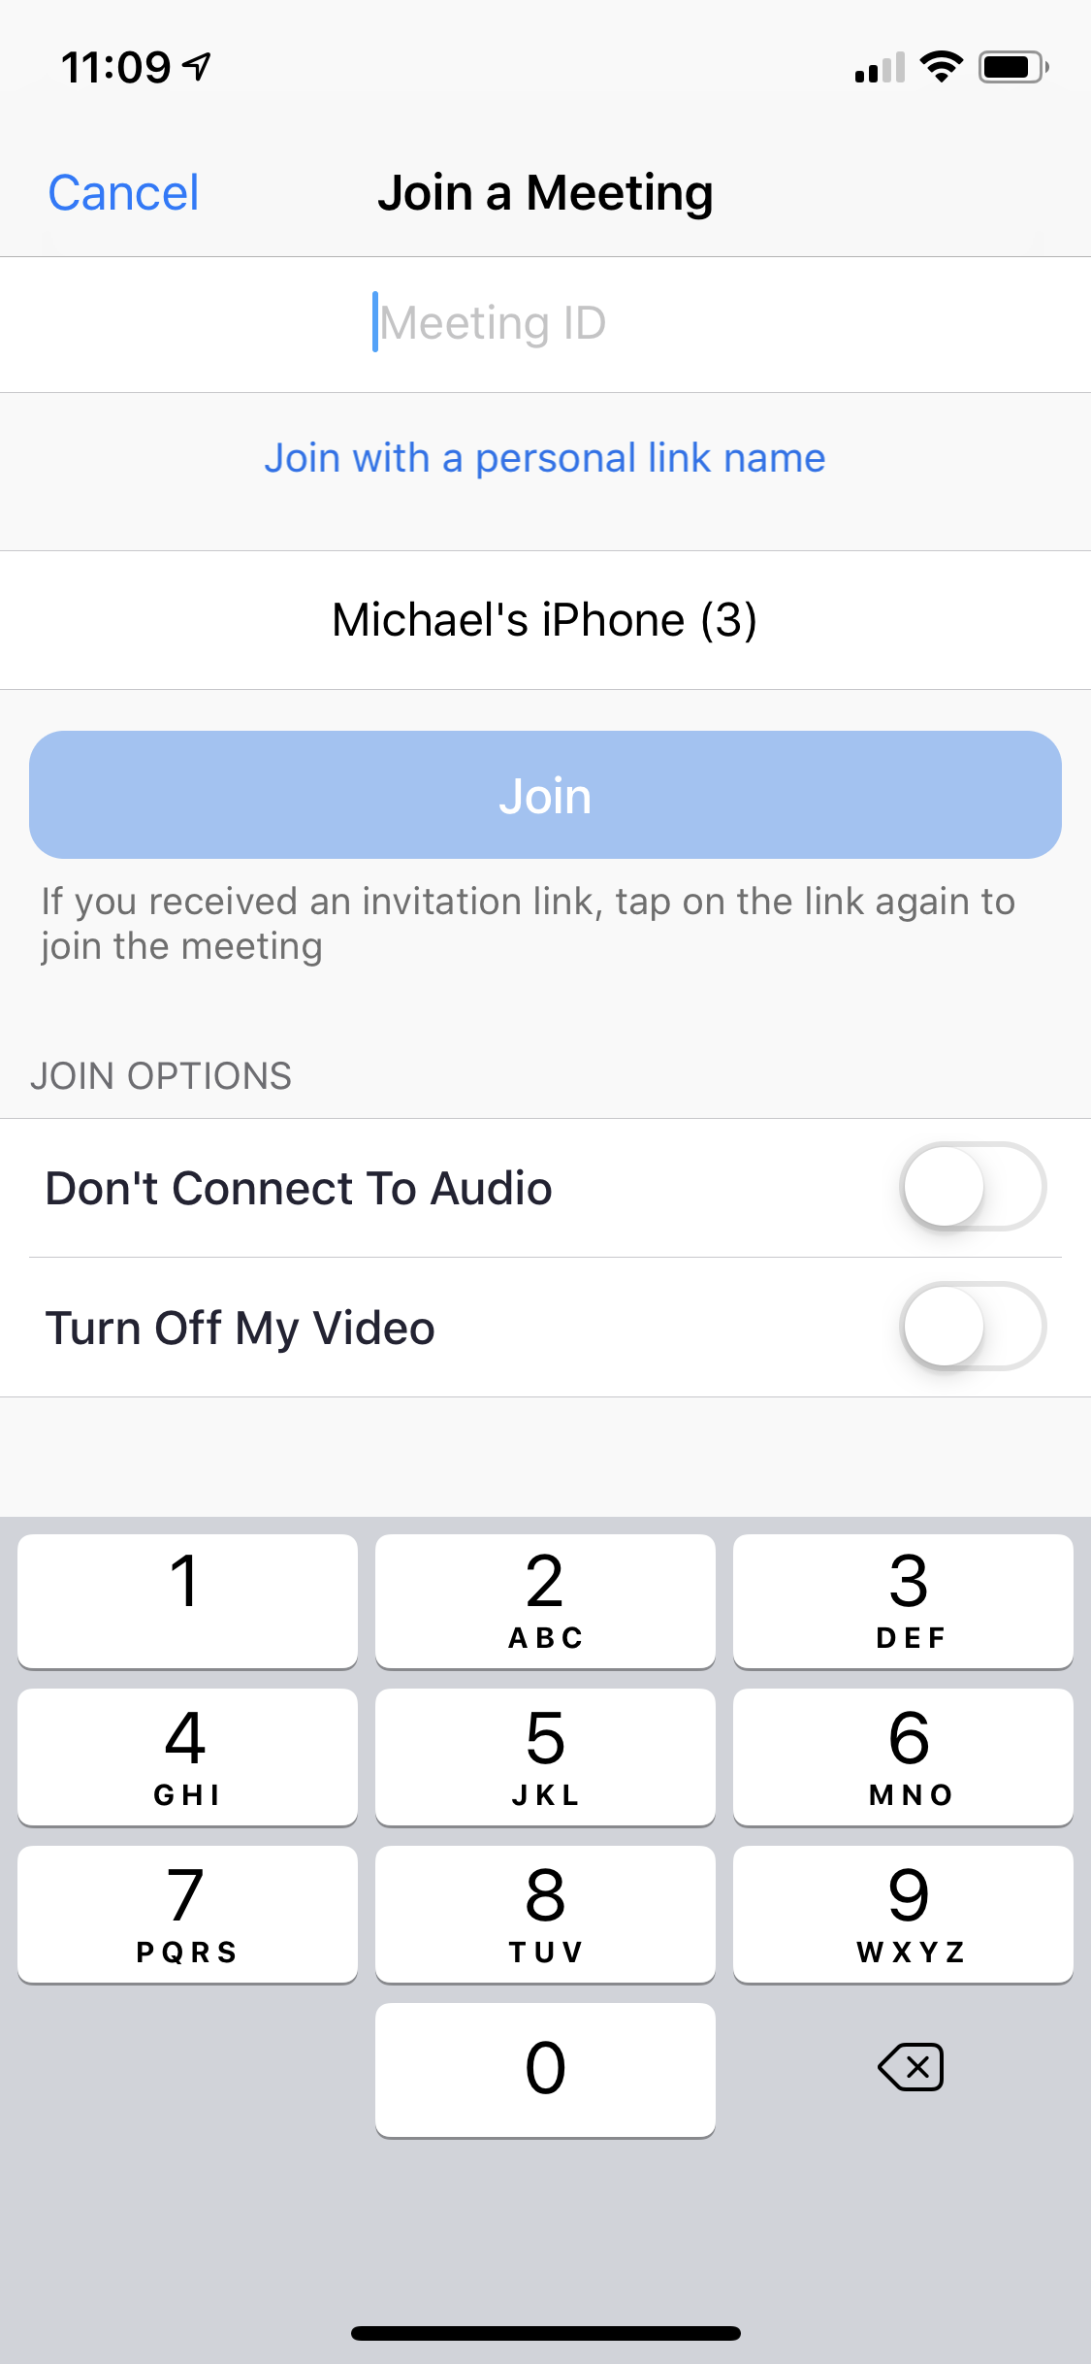

Fill in the screen with the Meeting ID.

Indicate if you want to connect both your audio and video. By default, we will automatically be able to see and hear you unless you choose otherwise.

Click “Join” and you’ll be added to the meeting!

I know all of this seems a little complicated. It’s actually not, as you will soon discover. :-)

Hope to see you online on Wednesday!

Call me if you have any questions at 561-236-0787.

:-)

B’Shalom,

Rabbi Resnick

