A Guide to Birkat Kohanim
Temple Emanu-El of Palm Beach
'May G-d bless you and guard you.’
'May G-d shine His countenance upon you and be gracious to you.’
'May G-d turn His countenance toward you and grant you peace.'
Numbers 6:24-26

Washing the Hands of the Kohen
- The Kohen is required to ritually wash and sanctify his/her hands before Birkat Kohanim.
- The al netilat yadayim blessing is not recited after this hand-washing.
- The hands should be washed in the closest possible time-proximity to the Birkat Kohanim (typically after the Kedushah is recited in the Repetition of the Amidah).
- The Torah conferred upon the tribe of Levi the privilege of assisting the Kohanim. Thus, the honor of washing the Kohanim's hands belongs to the Levites.
- If no Levite is in attendance, the Kohen should wash his/her own hands.
- Before washing the Kohen's hands, the Levite should wash his/her own hands.
- The Kohen's hands are washed as is customary when washing for bread—right hand three times and then left hand three times.
- The Kohen should not speak between the hand-washing and the Birkat Kohanim.

Removal of Shoes
- The Kohen removes his/her shoes before the Birkat Kohanim.
- The Kohen should remove his/her shoes before the washing of hands.
- Out of respect for the congregation, the shoes should not be strewn in the synagogue aisles. Instead, they should be neatly tucked out of sight, beneath a chair or table, for the duration of the blessing.

Moments before the Blessing
- The Hazzan’s beginning the Retzei blessing is the cue for the Kohanim to rise and make their way to the front of the sanctuary (all hands should be washed before this point). The Kohanim must start making their way to the front of the sanctuary when the chazzan begins this blessing.
- The Kohanim stand in front of the congregation facing the Ark.
- As the Hazzan finishes the Modim blessing, the Kohanim then cover their heads and upper body with their tallit and awaits the start of the Birkat Kohanim.

Calling Upon the Kohanim
- The Hazzan recites the prayer which precedes the Birkat Kohanim ("Our G-d and G-d of our fathers, bless us with the threefold [Priestly] Blessing…"), until he reaches the word "Kohanim"—which he proclaims out loud; officially summoning the Kohanim to discharge their priestly duty.
- The Hazzan then continues, "am kedoshecha ka'amur"
- At this point, the Kohanim – who are facing the Ark – rotate themselves clockwise to face the congregation and chant the blessing thanking God for "sanctifying us with Aaron's sanctity and commanding us to bless His nation Israel with love."
- Baruch Atah Adonai, Eloheinu Melech HaOlam Asher Kid’shanu B’kidushato shel Aaharon, V’tzi’vanu Lvarech et Amo Yisrael b’ahavah.

Raised Hands
- Immediately after the blessing, the Kohanim lift their hands beneath their tallits—shoulder-high, palms outstretched and facing downwards.
- The fingers are positioned in a manner which leaves "windows" through which G-d's blessings flow to the congregation.
- The Kohanim should not gaze at their hands during the Birkat Kohanim.

The Chazzan Leads
- The Hazzan then leads the Kohanim in the Birkat Kohanim. He recites aloud the fifteen words of the blessing:
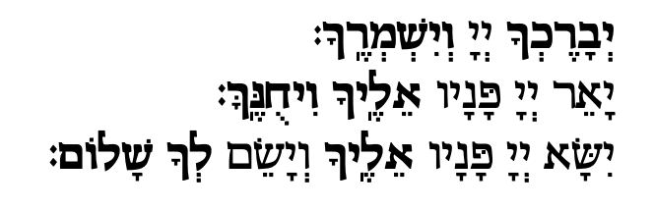
The Hebrew words are:
Yivarechecha
Adonai
viyishmirecha
#
Ya'er
Adonai
panav
elecha
veechuneka
#
Yeesa
Adonai
panav
elecha
viyasem
lecha
shalom
- The Kohanim repeat after the Hazzan word-for-word.
- The Kohanim must chant the words of the Birkat Kohanim in a loud voice—but not a shout.
- The Kohanim must wait for the Hazzan to completely conclude saying a word before repeating it.
- It is traditional in many communities for the Kohanim to precede the final word in each section with a short melody.
- After the conclusion of the Birkat Kohanim, the Kohanim remain facing the congregation until the Hazzan begins the Sim Shalom blessing. At this point they turn around – clockwise again – and only when they are once again facing the Ark may they bring down their outstretched hands.
- The Kohanim remain at the front of the sanctuary until the conclusion of Kaddish Shalem which immediately follows the Repetition of the Musaf Amidah.
- They then (put on their shoes) and file back to their places.

